# PROJECT REPORT

**Phase-II**

## On

**Mathematical Expression Solver**

Submitted to Rajasthan Technical University

in partial fulfillment of the requirement for the award of the degree of

# B.TECH.

## in

**COMPUTER ENGINEERING**

**Submitted By: -**

**Hitesh Soni (PIET16CE038)**

**Harsh Anand (PIET16CE033)**

**Madhuvrat Gupta (PIET16CE056)**

**Under the Guidance of**

**Mrs. Shruti Bijawat**

at



## POORNIMA INSTITUTE OF ENGINEERING & TECHNOLOGY, JAIPUR

**RAJASTHAN TECHNICAL UNIVERSITY, KOTA**

**CERTIFICATE**

This is to be certified that the project entitled “Handwritten Expression Solver” has been submitted for the Bachelor of Computer Science and Engineering, Poornima Institute of Engineering & Technology, Jaipur during the academic year 2019-2020 is a bonafide piece of project work carried out by “**Hitesh Soni, Harsh Anand, Madhuvrat Gupta**” towards the partial fulfillment for the award of

the Degree (B.Tech.) under the guidance of “**Shruti Bijawat**” and supervision and no part of thereof has been submitted by them for any degree or diploma.

|  |  |  |
| --- | --- | --- |
| Project Guide | Project Coordinator | Mr. Deepak Moud |
| Mrs. Shruti Bijawat  (Assistant Professor) | Prof. (Dr.) Rekha Jain (Professor) | (H.O.D CSE) |

# CANDIDATE’S DECLARATION

We, **Hitesh Soni** **(PIET16CE038), Harsh Anand (PIET16CE033) & Madhuvrat Gupta (PIET16CE056)** B.Tech (Semester- VIII) of “**Poornima Institute of Engineering & Technology, Jaipur”** hereby declare that the Project Report entitled **“Mathematical Expression Solver”** is an original work and data provided in the study is authentic to the best of our knowledge. This report has not been submitted to any other Institute for the award of any other degree.

|  |  |  |
| --- | --- | --- |
| **Hitesh Soni** | **Harsh Anand** | **Madhuvrat Gupta** |
| **(PIET16CE038)** | **(PIET16CE033)** | **(PIET16CE056)** |

### Place: Jaipur

**Date: 12 Mar 2020**

**ACKNOWLEDGEMENT**

It is our pleasure to be indebted to various people, who directly or indirectly contributed in the development of this work and who influenced our thinking, behavior and acts during the course of study.

We express our sincere gratitude to Prof***.*** (Dr)***.*** DineshGoyal***,*** Director, PIET for providing us an opportunity to undergo this Major Project as the part of the curriculum.

We are thankful to Mr. Deepak Moud***,*** HOD***,*** CSfor his support, cooperation, and motivation provided to us during the training for constant inspiration, presence and blessings.

We are thankful toMrs. Shruti Bijawatfor her support, cooperation, and motivation provided to us during the training for constant inspiration, presence and blessings.

We also extend our sincere appreciation to Prof. (Dr.) Rekha Jainwho provided her valuable suggestions and precious time in accomplishing our Project report.

Lastly, we would like to thank the almighty and our parents for their moral support and friends with whom we shared our day-to-day experience and received lots of suggestions that improved our quality of work.

|  |  |  |
| --- | --- | --- |
| **Hitesh Soni** | **Harsh Anand** | **Madhuvrat Gupta** |
| **(PIET16CE038)** | **(PIET16CE033)** | **(PIET16CE056)** |

# TABLE OF CONTENTS

|  |  |  |
| --- | --- | --- |
| **CHAPTER NO.** | **TOPICS** | **PAGE NO.** |
|  | TITLE PAGE |  |
|  | CERTIFICATE | 1 |
|  | CANDIDATE’S DECLARATION | 2 |
|  | ACKNOWLEDGEMENT | 3 |
|  | TABLE OF CONTENTS | 4-5 |
|  | LIST OF FIGURE | 6 |
|  | LIST OF TABLES | 7 |
|  | ABSTRACT | 8 |
| 1 | **INTRODUCTION** | 9-12 |
|  | Project Aim and Objective Problem Statement Software Requirements  Hardware Requirements |  |
| 2 | **LITERATURE SURVEY** | 13-14 |
| 3 | **PROJECT MANAGEMENT** | 15-21 |
|  | Project Integration Management Project Scope Management Project Time Management Project Cost Management Project Quality Management  Project Human Resource Management Project Communication Management Project Risk Management  Project Procurement Management Project Management Tools |  |
| 4 | **TECHNOLOGY APPLIED** | 22-30 |
|  | Agile project management and Scrum |  |

|  |  |  |
| --- | --- | --- |
|  | Core values of agile Principles of agile  Steps in the agile methodology POs and their relevance to project |  |
| 5 | **PRODUCT BACKLOG DESIGN** | 31-38 |
|  | Product Backlog Sprint Backlog-1 Sprint Backlog-2 Sprint Backlog-3 Sprint Backlog-4 |  |
| 6 | **PROJECT IMPLEMENTATION** | 39-44 |
|  | Sprint Backlog-1 Sprint Backlog-2 Sprint Backlog-3 Sprint Backlog-4 |  |
| 7 | **RESULTS** | 45-48 |
|  | Outcome  Benefits to society Future Scope |  |
|  | ANNEXURE (DST PROPOSAL) |  |
|  | REFERENCES | 49 |

**LIST OF FIGURES**

|  |  |  |  |
| --- | --- | --- | --- |
|  |  | | **PAGE NO.** |
| |  |  |  | | --- | --- | --- | | **S. NO.** | **FIGURE TITLE** | **PAGE No**. | | 1. | Fig 2.1 Raw image and preprocessed image | 13 | | 2. | Fig 2.2 Sample Image | 14 | | 3. | Fig 2.3 Text Recognition Process | 14 | | 4 | Fig 5.3 Sprint Backlog-1 Burn Down Chart | 33 | | 5. | Fig 5.5 Sprint Backlog-2 Burn Down Chart | 35 | | 6. | Fig 5.7 Sprint Backlog-3 Burn Down Chart | 37 | | 7. | Fig 5.8 Sprint Backlog-4 Burn Down Chart | 38 | | 8. | Fig 6.1 Expressions | 39 | | 9. | Fig 6.2 sample code for fetch and solve the expressions from image | 39 | | 10. | Fig 6.3 Result after solving the expression | 40 | | 11. | Fig 6.4 sample expressions | 40 | | 12. | Fig 6.5 UI | 41 | | 13. | Fig 6.6-6.7 sample code for UI connect with flask | 41 | | 14. | Fig 6.8 sample code of UI integrate with flask | 42 | | 15. | Fig 6.9 expression(stored in png) | 42 | | 16. | Fig 6.10 UI for our project | 43 | | 17. | Fig 6.11 Hand written expression | 43 | | 18. | Fig 6.12 sample code for training model | 43 | | 19. | Fig 6.13 sample flask app | 44 | | 20. | Fig 6.14 UI for hand written expression solver | 44 | | 21. | Fig 7.1 Home page for UI | 45 | | 22. | Fig 7.2 solution for handwritten expression | 46 | | 23. | Fig 7.3 differentiation problem solution | 47 | | 24. | Fig 7.4 Integration problem solution | 48 | | |
|  | |
|  | |
|  | |
|  | |
|  | |
|  | |
|  | |
|  | |
|  | |
|  | |
|  | |
|  | |

|  |  |
| --- | --- |
|  |  |
|  |
| **LIST OF TABLES**   |  |  |  |  |  | | --- | --- | --- | --- | --- | |  | |  |  | | | |  |  |  | | --- | --- | --- | | **S. NO.** | **TABLE NO. WITH TITLE** | **PAGE NO.** | | 1. | 5.1 Product Backlog | 31-32 | | 2. | 5.2 Sprint Backlog-1 | 32-33 | | 3. | 5.4 Sprint Backlog-2 | 34-35 | | 4. | 5.6 Sprint Backlog-3 | 36-37 | | 5. | 5.8 Sprint Backlog-4 | 38 | | | | | |  | | | |  | | | |  | | | | |  | | | |  | | | | |  | | | |  | | | | |  | | | |  | | | | |  | |  | | | | |  | | | |  | |  | | | | |  | | | |
|  |
|  |
|  |

|  |
| --- |
| **ABSTRACT**  Rapid growth of data comes with a challenge of sorting and analyzing them, where raw data exists in graphical form, textual form or in images. Data science and machine learning finds its application in various fields like stock market, recommendation systems, image processing, aerial photography, military, weather forecasting etc.  This report is about our project on “Mathematical Expression Solver” that addresses about data pre-processing and post processing which includes plotting, classification and prediction of result of algebraic expression and the ability of machine learning algorithms to deal with different set of data. In this project, we have tackled a prediction problem of an algebraic expression. We have used pytesseract library to solve the expression written in the image. In addition to this, we have also made use of several libraries to plot the data points on the map.  Subject Descriptors**:**  Web Technology  Software Engineering  Implementation Software and Hardware:  Windows, Spyder, Google Colab |

**CHAPTER 1**

**INTRODUCTION**

**Project Aim and Objective**: For centuries, handwritings had been the most common way of education. Nowadays, computers and the Internet are the indispensable way of modern communications; turning the planet into a little town. However, using handwritings in this education world is still something very appreciable and which remains possible, especially with the emergence of devices that rely on digital pens as an input method. Developing those devices was accompanied with the development of recognition systems capable of converting texts from our natural handwriting and vice-versa, into languages understandable by computers. This Project is solving the mathematical expression which can be handwritten or in image. First this will extract the expression from the image then this will identify the digits and operators. After identifying the digit and operators through the open cv and deep learning model. Now the expression is solved using python. This project can also solve the expressions containing the constant variables so this project is calculating the value of constant variables using appropriate method of mathematics. This will also provide the solution of the integration and differentiation problem with and without limits. Not only the single expressions but also the multiple expression can also be solved by this application. If there is a expression of degree two then this will solved it and calculate the multiple solution up to any possible limit. Not only the expression but also the power can also be calculated up to any limit and it can also solve the Boolean expression like >, <, == operators. This Project will identify the handwritten Mathematical expression identify the operators and operands from the handwritten expression and provide the solution. The handwritten expression can be in the form of images, written in any format like .txt,docs.

Many tools are available to achieve this task. However, most of those tools require some predefined knowledge to use them. Latex and MathML, for example, require knowledge of predefined sets of key words to declare the variables to use them in the math’s expression. Other tools, such as Math Type, depend on a visual environment to add symbols using the input through the keyboard which is a time consuming process. Our research focuses on the recognition of human handwritten mathematical expressions (ME).

**Problem Statement:** Identifying handwritten expression is the most difficult thing to do specially in the case of some digits like ‘/’ is very similar to ‘1’ in the math symbol and same case with ‘8’ and ‘0’ and so on. Identifying the alphabets in the math expression is also very difficult task to do like it is very difficult to identify the difference between ‘0’ and ‘o’ at the time to check for the constant variables in order to fetch the expression and solve it using the appropriate method of math and same with the case of two and more than three expressions. And also calculating the roots of quadratic expression specially in the case of negative roots is also very difficult thing to do. And also working with integration and differentiation in the case of handwritten is also a challenge to solve. Not only the in the case of simple problems but also in the case of some complex problems of same. There is no such tool available now which can work on all types of handwritten problems of math. And expression can also be in the form of images like there is an image in which an expression is specified so we have to extract the expression from the image and identify the operators and the digits and provide the correct solution of the expression. So there is no such application available on the net which can work on both the cases either for handwritten or in image form. There is some application available but accuracy is the major issues with them because if we not able to identify the digits then the results of calculation will always be wrong no matter any method we apply so major challenge is to identify the most accurate method by applying the all available machine learning and deep learning algorithms and after that select one which give us the higher accuracy then all. And also finding out the dataset is also the challenge for us because there is no large dataset available on internet. And because dataset is collected from multiple resources so that it may be differ. Now a day there is no such tools are available by which students can use it for getting the answer of any handwritten expression or any expression or writing any expression through keyboard input and get the answer. Like there is an assignment given to any student of math’s and he/she have to check the answers of math problems without checking the solution of the question it should show directly the answer so that students can verify their answers. There are calculators available for normal calculation even for scientific calculators are also available for the some hard problems through which we have to provide the inputs through the buttons and then only it provides us the result but the multiple problems with the calculator and there are as follows:- first problem with the calculator is that it will only work for simple arithmetic problems and some advance calculator can work with the trigonometric problems but it won’t work with the linear expression and quadratic expression for calculating the values for constant variables. Second problem with the calculator is that it will only with for input data it will not work for the handwritten data. Third problem with the calculator is that it will take input directly it won’t take an input image on which an expression is written and calculator is not capable enough to fetch the expression and provide the solution. Fourth problem with the calculator is that it is costly specially the scientific calculators are costlier than others. And there is such application available in the form of a website or app which is easily available on the internet and can solve all three types of problems like handwritten and image format and input driven on one website. Like if student have any doubt about any question then he simply have to write in an paper on his own language and click the photo of this handwritten expression and now upload this photo to the application named as handwritten expression solver and not this tool which extract the expression the expression form the image and display is on the screen so that user can identify the is it the same expression he has written and after clicking on the submit button this will show the results on the same screen same goes with the rest of two application. Like we are using the open cv in this application so there are many problems with the image like images may contain some noise which can cause problem in extraction like if an image contain the dot then this tool will extract it send it to the model for prediction and then out model will predict it as either zero or eight and same with the problem if there is any scratch on the image then out model will predict it as one or something so this fall our calculation wrong and will decrease the accuracy of our application. When designing the user interface of the application there is one more problem that is the library because some large library may cause the time complexity to increase. Being able to input a mathematical expression into a digital document could bea difficult process. Tools, likeLATEX or Math ML), aim at making it **a** neaterand more convivial process. However, complex expressions require much efforts and time. employingadigital pen presents a more natural thanks **to**input such expressions into digital documents.Some researchers are emerging in this area, especially on subclasses of mathematical expressions with some promising results. Most of research works consider recognition of mathematical expressions as a set of subtasks to perform different steps of the recognition process like digit recognition etc. Though, a main drawback comes from the fact that any error at any step will be automatically inherited to the next step, requiring further processing to be sure of a good and correct recognition results. Our contribution to the domain of handwritten mathematical expressions recognition is to perform a simultaneous segmentation, recognition and interpretation and solution of mathematical expressions. Specifically, the classifier wont to recognize the essential symbols is predicated on a worldwide learning method allowing the system to find out symbols directly from expressions rather than employing a pre-trained classifier. There are solution already available on the internet but there may be the possibility that there can be multiple possible answers of the same question then in this case student get confuse due to answers unmatched. But this application will provide the all the possible answers of the same question so that student will not get confused by the multiple answers and this application will also provide the answers up to any limit like in imaginary form as well

**Software Requirements: -**There are some software requirement which are as follows: -

* Anaconda
* Spyder
* Flask
* Sublime Text

**Hardware Requirements: -**There are some software requirement which are as follows: -

* Laptop
* Camera

**CHAPTER 2**

**LITERATURE SURVEY**

The study of human visual perception has quite a bit of overlap with topics of computer vision. At a high level, both our brains and the above algorithm perform a four-step process to read/interpret visual information.

1. Data collection
2. Data pre-processing
3. Segmentation
4. Recognition.

In the above application, data collection and pre-processing are accomplished via a webcam and OpenCV. A connection is made with a webcam from which frames are collected and sent to pre-processing functions written in python. These functions ultimately add Gaussian blur to the image before applying binary thresholding to make the characters more distinct from their background. The threshold employed should ideally be adaptive to match lighting conditions.

This cropping process is not trivial! To automatically detect/crop each character from the frame, a method of topological analysis is applied to first detect contours. Approximations of polynomial representations of each contour are then generated and minimum sized bounding rectangles enclosing each contour are estimated. I know, I know, I just glossed over a lot of details in the last two sentences. However, the references should get you started in the right direction if you're following along at home. And, like in many topics of computer vision, there are more than one way to verb a noun.



Fig 2.1 raw image and preprocessed image

After representing each character by a bounding rectangle, characters with unrealistic dimensions (too big relative to others, too small, overlapping, etc.) can be discarded as *noise*, so to speak. Each remaining character is then cropped from the original frame and resized (typically shrunk) to a predetermined dimension so that the CNN doesn't have to deal with huge or varying-sized inputs. Before feeding each character to the CNN's recognition logic, some local rules are applied to comprehend compound fractions.

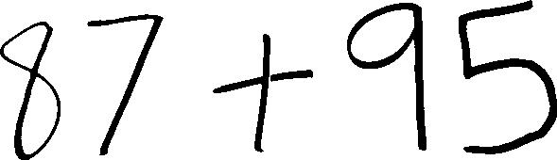

Fig 2.2 sample image

(Fig)

In the above example, the character is not only pre-processed, but also *segmented* from its frame that is, it's been cropped out. This cropping process is not trivial! To automatically detect/crop each character from the frame, a method of topological analysis is applied to first detect contours. Approximations of polynomial representations of each contour are then generated and minimum sized bounding rectangles enclosing each contour are estimated. I know, I know, I just glossed over a lot of details in the last two sentences. However, the references should get you started in the right direction if you're following along at home. And, like in many topics of computer vision, there are more than one way to verb a noun.

After representing each character by a bounding rectangle, characters with *unrealistic* dimensions (too big relative to others, too small, overlapping, etc.) can be discarded as *noise*, so to speak. Each remaining character is then cropped from the original frame 10 and resized (typically shrunk) to a predetermined dimension so that the CNN doesn't have to deal with huge or varying-sized inputs.

Before feeding each character to the CNN's recognition logic, some local rules are applied to comprehend compound fractions. After the Recognition part is over using CNN then we Basically concatenate the each and every characters. Then after getting the complete string we passed this to methods to find out the result of the expression.

**Text Recognition Process:**

Image Pre-processing

Insert Image which contains Expression

Feature Extraction & Normalization

Character Segmentation

Storing all character in single variable

Character Classifier

Fig 2.3 Text Recognition Process

**CHAPTER 3: PROJECT MANAGEMENT**

Project management has evolved from few simple principles to a wide subject with many complex concepts. To make it easier for people to understand project management, all PMBOK knowledge areas are classified into nine categories by PMBOK Guide. It is one of the most comprehensive model documents for project managers. In this article, we will take a deeper look at each of these knowledge areas to give you a better perspective of project management.

**1. Project Integration Management**

PMI defines project integration management as, “Processes and activities needed to identify, define, combine, unify and coordinate different processes and activities with project management process groups.” In short, project managers will have to keep an eye on every aspect of a project and check if everything is going according to the plan.

Good project integration is not possible without good teamwork. In order to be successful, you should have the resources who know their role and responsibilities. It is the responsibility of project managers to make project objectives clear and manage the inter-dependencies effectively to complete projects successfully. Therefore, project managers should focus on the bigger picture and follow a strategic approach to project management. Keep an eye on the obstacles and address them quickly before the problem gets out of hand.

**2. Project Scope Management**

Scope creep and lack of proper scope document is one of the main [reasons behind project failure](https://blog.taskque.com/causes-project-failure/). Furthermore, defining and documenting all the work comes under scope management. Project team should know what the deliverables are and what problems your project will solve. All this makes it easier for your team members to achieve the goals and helps clients in knowing what to expect from the projects. Therefore, project scope should also contain [milestones related to projects](https://blog.taskque.com/project-milestones-achieve/).

There are five sub-processes involved in the project scope management process.

* Collect requirements (Document stakeholder requirements)
* Define scope (Detailed description of project and what it will do)
* Create work breakdown structure (Dividing projects into smaller tasks)
* Verify scope (Getting acceptance of project deliverables from stakeholders)
* Control scope (Difference between actual and approved scope)

**3. Project Time Management**

One of the biggest challenges for project managers is to complete projects on time. However, most project managers do not understand this knowledge area. Hence, most projects under their supervision fail to complete before the deadline. There are six sub-processes associated with the project time management knowledge area that every project manager should know in order to complete projects on time.

Here are the six sub-processes:

* Define activities
* Sequence activities
* Estimate the resources required
* Estimate the time required
* Develop a schedule
* Control schedule

**4. Project Cost Management**

Most project managers consider managing costs against their project as their biggest challenge. However, cost management can be a difference maker between a successful project and a project failure. Many projects are abandoned due to budget constraints. If you do not want this to happen to your projects, then you should learn the art of effective project cost management and complete projects within the specified budgets. Latest tools and techniques can help you in this regard.

Here are three main sub-processes involved in project cost management.

* Estimate costs
* Determine budget
* Control costs

Make sure that you keep an eye on budget and expenditures so that you do not end up exceeding the budget. Unfortunately, most project managers do not pay attention to cost management from the beginning, spends a major chunk initially without any record and struggles to keep the project inside the budget later on. To keep project costs in check, you should track every dollar and where it is spent.

**5. Project Quality Management**

No matter how you define quality, a high-quality project is one which satisfies the customer needs and does not contain any defects and deficiencies. In order to achieve the highest project quality, project managers and their team should focus on customer requirements they have gathered initially, try to know what the customer wants and which problems your project will solve.

Develop a prototype of the project and give it to the end user to use it. Their feedback will allow you to make necessary adjustments before you deliver the final product to the customer. At the end of it all, the project should completely align with the user requirements in order to be called a high-quality project. Hence, all the requirements should be well documented so that your team can deliver a project that satisfies customer’s requirement.

**6. Project Human Resource Management**

Another knowledge area of project management that usually is ignored is project human resource management. It is the set of processes and activities involved in organizing, leading and managing project teams. It is how you manage the most valuable asset of your company i.e. people. To be successful at it, project managers should have a clear strategy when it comes to hiring and staffing people and inducting them into project teams. Hiring the right people can increase the chances of your success.

Project Human Resource Management process involves following sub-processes:

* Developing a human resource plan
* Hire the project team
* Develop a project team
* Manage project team

**7. Project Communication Management**

Poor project communications can wreak havoc on your project progress. Moreover, it can take your project towards failure. So, if you want to complete projects successfully, all team members should be on the same page. Moreover, they should work as a team to achieve the common objective. If you want that to happen, then you will have to communicate effectively and regularly. Project managers can enhance collaboration and communication among their team members by using [task management software](https://taskque.com/) that offers communications and collaboration features. Here are some of the key activities that project managers need to undertake to ensure uninterrupted communications throughout the project:

* Identify stakeholders
* Plan communications
* Distribute information
* Manage stakeholder expectations
* Report performance

**8. Project Risk Management**

Most project managers consider risk management as the most important factor in completing projects successfully. Therefore, effective risk management plays an important role in preventing your projects from failure. In addition to this, project managers can reduce the risk by following a proactive approach and managing risks at the initial stage. Project managers who ignore minor risks have to suffer from project failure because these minor risks can turn into major risk and can lead to a project disaster if left unattended. Here are some of the activities that project managers will have to undertake in project risk management:

* Plan risk management
* Identify risks
* Perform qualitative and quantitative risk analysis
* Plan risk response
* Monitor and control risks

**9. Project Procurement Management**

The Project Procurement Management knowledge area covers all the aspects related to purchase and acquiring of products and services needed to complete projects effectively. Although, the procurement process is quite transparent and conducted through a contract or agreement, it important for project managers to ensure that there are no discrepancies. Whether you are a buyer or seller, you need to understand both perspectives to get a better knowledge of the project procurement process. Additionally, cost benefit analysis, cost utility analysis, and risk analysis also comes under project procurement management.

* Plan procurement
* Conduct procurement
* Administer procurement
* Close procurement

**Project Management Tools:**

Project management required tools to manage the work, time and resources. At present many of the software are available for project management. Some of the popular software tools are as follows.

### 01. [Trello](http://send.getapp.com/aff_c?offer_id=677&aff_id=1371)

Trello is a project management tool, instead this app is a free visual way to glance at the entire project with a single view. With Trello you can organize cards, these cards can be your thoughts, conversations and to-do lists and be placed on a board for everyone to collaborate on.

### 02. [Basecamp](http://send.getapp.com/aff_c?offer_id=637&aff_id=1371)

Basecamp is the granddaddy of project management apps. Basecamp is considered the leading project management tool around. It boosts a simple and easy to use interface to collaborate with your team and client. It allows you to create multiple projects and setup discussions, write to-do lists, manage files, create and share documents, and organize dates for scheduling.

### 03. [Teamwork Projects](http://send.getapp.com/aff_c?offer_id=947&aff_id=1371)

Teamwork Projects is the ultimate productivity tool to manage projects with your team. Teamwork allows you to keep all your projects, tasks and files all in one place and easily collaborate with a team. Teamwork helps you to visualize the entire project through a marked calendar and Gantt chart and setup reporting. Teamwork supports file management with Google Drive, Box.com and Dropbox. As well as integration with leading apps such as third party accounting software and customer support apps.

### 04. [Resource Guru](https://resourceguruapp.com/)

Billed as the "simple way to schedule people, equipment and other resources", Resource Guru is a streamlined resource scheduling and leave management tool that’s designed to keep your projects on track. You can plan your team's workloads, receive daily booking reminders, report on KPIs, and more. Apple, Saatchi & Saatchi and Deloitte are among some of the cloud-based team calendar’s heavyweight customers.

### 05. [ActiveCollab](http://send.getapp.com/aff_c?offer_id=949&aff_id=1371)

ActiveCollab recently released its new version 5.0. The new revamped app is now more powerful and focused project management tool. It offers team collaborating features, task management, time tracking and importing expenses. One of the biggest asset of ActiveCollab is it offers invoicing features. You are able to track payments and expenses and have invoices paid directly within ActiveCollab with PayPal, and other credit card payments.

### 06. [Zoho Projects](http://send.appdoubler.com/aff_c?offer_id=101&aff_id=1371)

Zoho offers a wide range of business software including Projects. Zoho Projects is a proficient tool to project plan and project coordinator from start to finish. It boosts all the features you need for project management with some advance features including reporting, integration with Google Apps and Dropbox, bug tracking, setup Wiki Pages to build a repository of information, forums and more.

### 07. [Jira](http://send.getapp.com/aff_c?offer_id=281&aff_id=1371)

Jira is specifically targeted for software development teams. Jira offers abilities to raise issues and bugs. Jira makes it really easy to track bugs and see which issues are still outstanding and how much time was spent on each task. Jira offer other products including Confluence a document collaboration tool, and HipChat a team chat and video and file sharing platform and other products.

### 08. [Asana](http://send.getapp.com/aff_c?offer_id=587&aff_id=1371)

Asana is the easiest way for teams to track their work so everyone knows who's doing what, by when. With tasks, projects, conversations and dashboards, Asana keeps your work organized, and teammates accountable so you can move work forward faster. Asana also lets you keep track of your work wherever you are with mobile apps for both iOS and Android.

### 09. [Podio](http://send.getapp.com/aff_c?offer_id=951&aff_id=1371)

Podio is an ever growing tool to organize and communication tool for any business. Podio allows you to personalize this platform to fit your business needs. Besides being able to communicate with a team, setup task management, use as a file storage system, like a traditional project management app, Podio can be an internal intranet for all your colleagues and departments to interact.

### 10. [Freedcamp](https://freedcamp.com/)

Whatever your project may be, either setting up an event, a web project or organizing a wedding, Freed camp helps you organize and plan effectively. Freed camp has an organized dashboard to view the entire project at a glance. You can easily setup tasks, use sticky notes to visually setup tasks and organize them into the calendar. Freed camp provides advance add-ons for high level business use including CRM, invoicing, issue tracking and setting up wiki pages.

### 11. [Wrike](http://send.getapp.com/aff_c?offer_id=239&aff_id=1371)

Wrike is advance application to help you work smarter. By making sure you are always staying on track and ensure you have the adequate resources to finish on time and on budget. Setting up tasks, engage your team and integrate with your business tools including Google Apps, Microsoft Excel, Dropbox and many more is so easy with Wrike.

**CHAPTER 4: TECHNOLOGY APPLIED**

Agile is a [project management methodology](https://www.cio.com/article/2950579/methodology-frameworks/how-to-pick-a-project-management-methodology.html) that uses short development cycles called “sprints” to focus on continuous improvement in the development of a product or service.

Although incremental software development methods go as far back as 1957, agile was first discussed in depth in the 1970s by William Royce who published a paper on the development of large software systems. Later in 2001, the Agile Manifesto, a "formal proclamation of four key values and 12 principles to guide an iterative and people-centric approach to software development," was published by 17 software developers. These developers gathered together to discuss lightweight development methods based on their combined experience.

**Agile project management and Scrum**

[Scrum](https://www.cio.com/article/3223139/project-management/what-is-a-scrum-master-a-key-role-for-project-success.html) is a powerful framework for implementing agile processes in software development and other projects. This highly adopted framework utilizes short iterations of work, called sprints, and daily meetings, called scrums, to tackle discrete portions of a project in succession until the project as a whole is complete. There are three key roles within Scrum: the [Scrum master](https://www.cio.com/article/3223139/project-management/what-is-a-scrum-master-a-key-role-for-project-success.html), product owner, and Scrum team members:

* The product owner creates and prioritizes a product backlog (work to be done).
* Teams select items from the backlog and determine how to complete the work.
* Work must be completed within a sprint (usually two to four weeks).
* The Scrum master meets with teams briefly each day to get progress updates.
* Sprint reviews are conducted at the end of each sprint.
* The process starts again until all work or backlog is complete.

Agile project management is a modern, flexible approach to [project management](https://www.workfront.com/solutions/project-management-software/). It allows you to break large projects down into more manageable tasks, which are tackled in short iterations or sprints. This enables your team to adapt to change quickly and deliver work fast.

Today, agile project management methodology is used by software developers, construction companies, educational organizations, and even [marketing teams](https://www.workfront.com/solutions/marketing). Many organizations can benefit from agile project management, and it’s simple to set up and utilize.

While you can take advantage of software, books, or agile coaches, each agile team is unique, and understanding the basics can help you put together an agile project methodology that works for you and your team.

## Core values of agile

The Agile Manifesto outlines 4 core values and 12 guiding principles which are important for any team adopting an agile methodology.

Those 4 core values are:

### **1. Individuals and interactions over processes and tools**

As sophisticated as technology gets, the human element will always serve as an important role in any kind of project management. Relying too heavily on processes and tools results in an inability to adapt to changing circumstances.

### **2. Working software over comprehensive documentation**

As important as documentation is, working software is more. This value is all about giving the developers exactly what they need to get the job done, without overloading them.

### **3. Customer collaboration over contract negotiation**

Your customers are one of your most powerful assets. Whether internal or external customers, involving them throughout the process can help to ensure that the end product meets their needs more effectively.

### **4. Responding to change over following a plan**

This value is one of the biggest departures from traditional project management. Historically, change was seen as an expense, and one to be avoided. Agile allows for continuous change throughout the life of any given project. Each sprint provides an opportunity for review and course correction.

## Principles of agile

Agile project methodologies can be as diverse and unique as each individual team, but **these 12 principles should always guide your decisions and product development**.

1. Our highest priority is to satisfy the customer through early and continuous delivery of valuable software (or whatever else you deliver).
2. Welcome changing requirements, even late in development. Agile processes harness change for the customer’s competitive advantage.
3. Deliver projects frequently, from a couple of weeks to a couple of months, with a preference for the shorter timescale.
4. Coordinating team members must work together daily throughout the project.
5. Build projects around motivated individuals. Give them the environment and support they need and trust them to get the job done.
6. Face-to-face conversation is the most efficient and effective method of conveying information to and within different teams.
7. The final product is the primary measure of progress.
8. Agile processes promote sustainable development. All stakeholders should be able to maintain a constant pace indefinitely.
9. Continuous attention to technical excellence and good design enhances agility.
10. Simplicity—the art of maximizing the amount of work not done—is essential.
11. The best architectures, requirements, and designs emerge from self-organizing teams.
12. At regular intervals, the team reflects on how to become more effective, then tunes and adjusts its behavior accordingly.

## The team members

Each agile project methodology has its own unique list of team members, and while the titles may change, there are a few universal [characteristics that agile team members](https://www.workfront.com/blog/building-and-growing-an-agile-marketing-team-with-andrea-fryrear) should have:

1. **T-shaped.** A valuable team member has a wide breadth of basic knowledge about their subject but also deep knowledge, experience, and ability in one (or more) specific areas.
2. **Cross-functional.** Cross-functional team members have skills outside their traditional areas. They might know some basic graphic design principles and data analysis or even some HTML/CSS.
3. **Adaptable.** If they have a diverse skill set, they know how to use it. No matter the environment, their output remains consistent.
4. **Curious.** Part of optimizing and becoming more efficient is asking the right questions and challenging the way things have always been when it’s appropriate.
5. **Entrepreneurial.** An agile team member is one that doesn’t wait to be told what to do. They’re ready to fill in and develop campaigns where they see a need.
6. **Team-oriented.** Team players prioritize the success of the team over their own personal glory. If everyone is delivering on time and syncing well together, they see that as a win.
7. **Committed to excellence.** One of the key benefits of agile projects is delivering quality work, faster. Team members who are committed to excellence don’t settle for average. They’re not hung up on perfection, but they’re dedicated to always producing their best work.

## Steps in the agile methodology

The goal of agile is to produce shorter development cycles and more frequent product releases than traditional waterfall project management. This shorter time frame enables project teams to react to changes in the client’s needs more effectively.

[Scrum](https://www.workfront.com/blog/rolling-out-scrum-on-your-marketing-team-part-1-with-andrea-fryrear) and [Kanban](https://www.workfront.com/blog/rolling-out-kanban-with-andrea-fryrear) are two of the most common. But each agile project methodology will follow [the same basic process](http://www.dummies.com/careers/project-management/agile-project-management-for-dummies-cheat-sheet/), which includes:

### 1. Project planning

Like with any project, before beginning your team should understand the end goal, the value to the organization or client, and how it will be achieved.

Project scope can be developed here, but **remember that the purpose of using agile project management is to be able to address changes and additions to the project easily**, so the project scope shouldn’t be seen as unchangeable.

### 2. Product roadmap creation

A roadmap is a breakdown of the features that will make up the final product. This is a crucial component of the planning stage, because team will build these individual features during each sprint.

At this point, a product backlog is developed, which is a list of all the features and deliverables that will make up the final product.

### 3. Release planning

In traditional waterfall project management, there is one implementation date that comes after an entire project has been developed. When using an agile project methodology, project uses shorter development cycles (called sprints) with features released at the end of each cycle.

Before kicking off the project, a high-level plan is prepared for feature releases and at the beginning of each sprint, revisit and reassess of the released plan is performed.

### 4. Sprint planning

Before each sprint begins, the stakeholders need to plan what will be accomplished by each person during that sprint, how it will be achieved, and assess the task load. It’s important to share the load evenly among team members so they can accomplish their assigned tasks during the sprint.

It is also needed to [visually document your workflow](https://www.workfront.com/blog/how-to-visualize-your-agile-marketing-workflow-and-why-you-should-with-andrea-fryrear) for team transparency, shared understanding within the team, and identifying and removing bottlenecks.

### 5. Daily meetings

To help team accomplish their tasks during each sprint and assess whether any changes need to be made, hold short daily meetings. During these meetings, each team member will briefly talk about what they accomplished the day before and what they will be working on that day.

**These daily meetings should be only 15 minutes long.** They aren’t meant to be extended problem-solving sessions or a chance to talk about general news items. Some teams will even hold these meetings standing up to keep it brief.

### 6. Sprint review and retrospective

After the end of each sprint, team will hold two meetings: first, a sprint review with the project stakeholders to show them the finished product. This is an important part of keeping open communication with stakeholders.

An in-person or video conference meeting allows both groups to build a relationship and discuss product issues that arise.

Second, a sprint retrospective meeting with stakeholders to discuss what went well during the sprint, what could have been better, whether the task load was too heavy or too light for each member, and what was accomplished during the sprint.

If team is new to agile project management, don’t skip this essential meeting. It helps to estimate how much team can tackle during each sprint and the most efficient sprint length for future projects.

## POs and Their Relevance to project

**PO1: Engineering knowledge:** Apply the knowledge of mathematics, science, engineering fundamentals and an engineering specialization to the solution of complex engineering problems.

In this project creation process engineering knowledge of the software engineering and Electronics engineering have been applied. we have used software engineering, HTML, XML, JAVA, Android, Java Script, PHP, J2EE, Data Base, Oracle, MYSQL, MONGO-DB and other programming language and database to the project. We have applied all above engineering subjects in our projects.

**PO2: Problem analysis:** Identify, formulate, review research literature, and analyze complex engineering problems reaching substantiated conclusions using first principles of mathematics, natural sciences, and engineering sciences.

In our projects we have identified an problem , once verified by the client we have worked to identify the solution using all of our theoretical and practical knowledge.

**PO3: Design/development of solutions:** Design solutions for complex engineering problems and design system components or processes that meet the specified needs with appropriate consideration for the public health and safety, and the cultural, societal, and environmental considerations.

**PO4: Conduct investigations of complex problems:** Use research-based knowledge and research methods including design of experiments, analysis and interpretation of data, and synthesis of the information to provide valid conclusions.

**PO5: Modern tool usage:** Create, select, and apply appropriate techniques, resources, and modern engineering and IT tools including prediction and modelling to complex engineering activities with an understanding of the limitations.

In the project development we have applied Integrated Development Environment IDE for the rapid development of the code, used web server for the software development.

**PO6: The engineer and society**: Apply reasoning informed by the contextual knowledge to assess societal, health, safety, legal and cultural issues and the consequent responsibilities relevant to the professional engineering practice.

In 1961, the Conference of Engineering Societies of Western Europe and the United States of America defined "professional engineer" as follows.

A professional engineer is competent by virtue of his/her fundamental education and training to apply the scientific method and outlook to the analysis and solution of engineering problems. He/she is able to assume personal responsibility for the development and application of engineering science and knowledge, notably in research, design, construction, manufacturing, superintending, managing and in the education of the engineer. His/her work is predominantly intellectual and varied and not of a routine mental or physical character. It requires the exercise of original thought and judgement and the ability to supervise the technical and administrative work of others. His/her education will have been such as to make him/her capable of closely and continuously following progress in his/her branch of engineering science by consulting newly published works on a worldwide basis, assimilating such information and applying it independently. He/she is thus placed in a position to make contributions to the development of engineering science or its applications. His/her education and training will have been such that he/she will have acquired a broad and general appreciation of the engineering sciences as well as thorough insight into the special features of his/her own branch. In due time he/she will be able to give authoritative technical advice and to assume responsibility for the direction of important tasks in his/her branch.

**PO7: Environment and sustainability:** Understand the impact of the professional engineering solutions in and environmental contexts, and demonstrate the knowledge of, and need for sustainable development.

Sustainability is the ability to continue a defined behavior indefinitely. Sometimes environmental, social and economic are termed to be the three pillars of sustainability.

**PO8: Ethics**: Apply ethical principles and commit to professional ethics and responsibilities and norms of the engineering practice. Engineers uphold and advance the integrity, honor and dignity of the engineering profession by:

1. Using their knowledge and skill for the enhancement of human welfare;
2. being honest and impartial, and servicing with fidelity the public, their employers and clients;
3. Striving to increase the competence and prestige of the engineering profession; and
4. Supporting the professional and technical societies of their disciplines.

**PO9. Individual and Team work**: Function effectively as an individual and as a member or leader in diverse teams, and in multidisciplinary settings.

To work successful in team a team member must have following capabilities.

**1. The Ability to Listen**

it is important to listen to one another's ideas. Too often in a business setting, you have a group of people simply waiting for their turn to speak, not paying one iota of attention to the persons on their left or right. So it is a good teamwork skill to have the ability to listen

**2. Check Your Ego**

This isn't saying abandon your ego all together, because that isn't healthy. But leaving your ego at the door temporarily is a very important team work skill. The reason this is so essential is because there is always someone better than you at something, no matter how brilliant you are.

**3. Critique**

By critique, I mean constructive criticism. Be able to give others constructive criticism and be able to listen to others critique your ideas and work. There shouldn't be any offense taken to constructive criticism. You all want to succeed, and this is a vital step in doing so.

**4. Delegation**

The mentality must be applied to teamwork. Delegate roles to those who do them best.

**5. Show Respect**

If you and another person happen to be paired up and can't stand each other, you can still put that aside for a couple of hours, treat each other civilly, and complete the tasks at hand. You may even overcome the dislike toward one another.

**6. Be Helpful**

This is simple. If one of your teammates does not understand an idea, discussion, or task that is being completed, take the necessary time to explain it to them and work with them. There are no weak links when everyone helps one another. Some take longer to learn than others, but that doesn't mean that they are of less intelligence. If in a meeting someone asks a question because they don't understand, don't frown at them. Just answer the questions patiently and concisely.

**7. Question One Another**

If someone brings up a topic of discussion and a solution to this topic, question them. Respectfully question, don't badger. Rather, ask them how it will work, why it will work over the long-run, and how everyone else can implement the idea.

**8. Participation**

Have the entire team encourage shy people to engage in the topics of discussion. Don't demand it, but make them realize that you really want to hear their ideas.

**9. Rational Debate**

Bad ideas are bad for teams. Spirited, friendly, rational debate is where facts come forward, ideas are born, and quality rises to the top.

**10. Set the Right Environment**

Try to make the space in which your team is assembled as comfortable, relaxing, and inviting as possible. You do not want your team to be tense and with frayed nerves.

**PO 10: Communication:** Communicate effectively on complex engineering activities with the engineering community and with society at large, such as, being able to comprehend and write effective reports and design documentation, make effective presentations, and give and receive clear instructions.

**PO11: Project Management and Finance:** Demonstrate knowledge and understanding of the engineering management principles and apply these to one’s own work, as a member and leader in a team, to manage projects and in multidisciplinary environments.

Project management is the application of processes, methods, knowledge, skills and experience to achieve the project objectives. In general project is a unique, transient endeavour, undertaken to achieve planned objectives, which could be defined in terms of outputs, outcomes or benefits.

**PO12: Life-long learning**: Recognize the need for and have the preparation and ability to engage in independent and lifelong learning in the broadest context of technological change.

Life Long Learning means is the provision or use of both formal and informal learning opportunities throughout people's lives in order to foster the continuous development and improvement of the knowledge and skills needed for employment and personal fulfillment

**Chapter 5: Product Backlog Design**

**Product Backlog**

Product Backlog refinement is that the act of adding detail, estimates, and order to items within the Product Backlog. this is often an ongoing process during which the merchandise Owner and therefore the Development Team collaborate on the small print of Product Backlog items. During Product Backlog refinement, items are reviewed and revised.

The product backlog is that the single authoritative source for things that a team works on. meaning that nothing gets done that isn’t on the merchandise backlog. Conversely, the presence of a product backlog item on a product backlog doesn't guarantee that it'll be delivered. It represents an option the team has for delivering a selected outcome instead of a commitment.

Product backlog items take a spread of formats, with user stories being the foremost common. The team using the merchandise backlog determines the format they chose to use and appearance to the backlog items as reminders of the aspects of an answer they'll work on.

|  |  |  |  |  |  |  |  |
| --- | --- | --- | --- | --- | --- | --- | --- |
| **SPRINT BACKLOG** | **US ID** | **BACKLOG ITEM** | | | **PRIORITY** | **RESPONSIBLE** | **ESTIMATE DATE** |
| **AS A/AN** | **I WANT TO** | **SO THAT** |
| 1 | SB1/US1 | Developer | understand required technology | I can implement | 1 | HS+HA+MG | 09/04/2019 |
| 1 | SB1/US2 | Developer | configure machine | I can use that | 1 | HS+HA+MG | 09/04/2019 |
| 1 | SB1/US3 | Developer | create expression's image | It can be use for testing | 1 | HS+HA+MG | 09/18/2019 |
| 1 | SB1/US4 | Developer | extract text from image | It can be evaluated | 1 | HS+HA+MG | 09/25/2019 |
| 1 | SB1/US5 | Developer | test the result | result can be enhanced | 1 | HS+HA+MG | 09/25/2019 |
| 2 | SB2/US1 | Developer | Design UI | I get better results | 2 | HS+HA+MG | 10/02/2019 |
| 2 | SB2/US2 | Developer | deploy Flask | I will use functions of it | 2 | HS+HA+MG | 10/14/2019 |
| 2 | SB2/US3 | Developer | apply AJAX | I can handle dataset | 2 | HS+HA+MG | 10/14/2019 |
| 2 | SB2/US4 | Developer | Design textbox | I can use data frame | 2 | HS+HA+MG | 10/25/2019 |
| 2 | SB2/US5 | Developer | integration of all modules | I can clean the data | 2 | HS+HA+MG | 10/25/2019 |
| 3 | SB3/US1 | Developer | method to find out roots of an expression | prepared a list of it | 3 | HS+HA+MG | 12/18/2019 |
| 3 | SB3/US2 | Developer | method to find out roots of multiple expressions | I fill the missing values | 3 | HS+HA+MG | 10/25/2019 |
| 3 | SB3/US3 | Developer | method to find out differentiation | I applied suitable techniques | 3 | HS+HA+MG | 10/25/2019 |
| 3 | SB3/US4 | Developer | method to find out integration | I create graph | 3 | HS+HA+MG | 1/2/2020 |
| 3 | SB3/US5 | Developer | integration of all modules | I can visualize the noise | 3 | HS+HA+MG | 1/2/2020 |
| 4 | SB4/US1 | Developer | Prepare the environment for neural network | I dropped it | 4 | HS+HA+MG | 1/9/2020 |
| 4 | SB4/US2 | Developer | prepare and collect dataset | I did not get error | 4 | HS+HA+MG | 1/9/2020 |
| 4 | SB4/US3 | Developer | create model | Data frame will be sequenced | 4 | HS+HA+MG | 1/16/2020 |
| 4 | SB4/US4 | Developer | testing of the model | remove extra columns | 4 | HS+HA+MG | 1/16/2020 |
| 4 | SB4/US5 | Developer | Test the complete flask app | I can get some insights of data | 4 | HS+HA+MG | 1/23/2020 |

Fig 5.1 Product Backlog

**Sprint Backlog- 1**

The sprint backlog could also be an inventory of tasks identified by the Scrum team to be completed during the Scrum sprint. During the meeting of sprint planning, the team selects some number of product backlog items, usually within the type of user stories, and identifies the tasks necessary to end each user story.

Most teams also estimate what percentage hours each task will take someone on the team to end. The sprint backlog is typically maintained as a spreadsheet and it is also possible to use our detect defect tracking system or any of sort of software products designed specifically for Scrum.

Our Sprint Backlog-1 is basically based on the understand the requirements of tools & technologies, understand the future scope of the project, select the appropriate language to work on the project, install the required libraries to configure the system and create a model that extract simple expression from the image and solve that expression extracted from image. For starting phase generate the expression in image with the help of MS-Paint software. After getting the result test the accuracy of the program.

|  |  |  |  |  |  |  |
| --- | --- | --- | --- | --- | --- | --- |
| **US ID** | **USER STORY** | **TASK ID** | **TASKS** | **TM** | **STATUS (NOT STARTED / IN PROGRESS / COMPLETED)** | **ESTIMATED DATE OF TASK COMPLETION** |
| SB1/US1 | Understand the tools and technologies | SB1/US1/T1 | understand requirement of project | HS+HA+MG | Completed | 4-Sep-19 |
| SB1/US1/T2 | choose appropriate language of technologies | HS+HA+MG | Completed | 4-Sep-19 |
| SB1/US1/T3 | search the desired modules and dataset | HS+HA+MG | Completed | 4-Sep-19 |
| SB1/US1/T4 | search the required libraries used in Project | HS+HA+MG | Completed | 4-Sep-19 |
| SB1/US2 | configure machine | SB1/US2/T1 | install the required libraries for the selected language | HS+HA+MG | Completed | 4-Sep-19 |
| SB1/US2/T2 | set the path for the complete project | HS+HA+MG | Completed | 4-Sep-19 |
| SB1/US2/T3 | install the required libraries according to requirements | HS+HA+MG | Completed | 4-Sep-19 |
| SB1/US2/T4 | run the sample code for testing the configuration | HS+HA+MG | Completed | 18-Sep-19 |
| SB1/US3 | create expression's image | SB1/US3/T1 | create expression in MS-Paint | HS+HA+MG | Completed | 18-Sep-19 |
| SB1/US3/T2 | store the image in png format | HS+HA+MG | Completed | 18-Sep-19 |
| SB1/US3/T3 | store multiple type of expression | HS+HA+MG | Completed | 18-Sep-19 |
| SB1/US3/T4 | store all the image at specific location | HS+HA+MG | Completed | 18-Sep-19 |
| SB1/US4 | extract text from image | SB1/US4/T1 | install the pytesseract | HS+HA+MG | Completed | 18-Sep-19 |
| SB1/US4/T2 | apply pytesseract and filter to extract text from image | HS+HA+MG | Completed | 25-Sep-19 |
| SB1/US4/T3 | store the text extracted from image | HS+HA+MG | Completed | 25-Sep-19 |
| SB1/US5 | test the result | SB1/US5/T1 | evaluate the extracted text using programming | HS+HA+MG | Completed | 25-Sep-19 |
| SB1/US5/T2 | check the result is appropriate or not | HS+HA+MG | Completed | 25-Sep-19 |
| SB1/US5/T3 | check the result on multiple expression | HS+HA+MG | Completed | 25-Sep-19 |

Fig 5.2 Sprint Backlog

**Sprint Backlog- 1 Burn Down Chart**

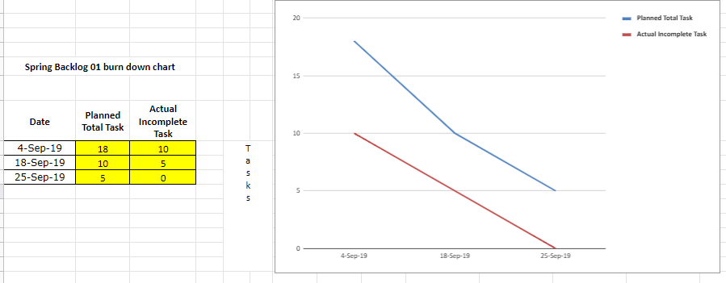

Fig 5.3

**Sprint Backlog- 2**

During Sprint Backlog 2, the Implementation Team must find out the way to solve the matter it took on in Sprint Backlog 1. This consists of two parts:

• A solution concept - a design, architecture or whatever, which explains how the matter is to be solved/feature is to be realized.

• A list of tasks - what steps must the team do to urge each selected backlog item to the state 'done'.

In Sprint Backlog 1, I even have found it effective when the team members add pairs during a solve-present-solve-present sequence. The feedback we will get from previous, we will get chance to enhance, modify or possibly even rethink the concept. Again working in pairs, we can create task cards, showing the route to "done." Finally, each pair presents these tasks to the whole team.

Our Sprint Backlog 2 is based on designing the UI with the help of HTML, CSS, Bootstrap, JavaScript and deploy the python code with UI can be done with the help of Flask app. In UI, we have design an input box that take file(image) as input and after taking input it displays the image in another box and after click on submit it display the result on same page. Without reloading the UI, we have to display the result, so that we can use AJAX. At last create a Text box in UI, so that we can type the expression also rather taking images every time.

|  |  |  |  |  |  |  |
| --- | --- | --- | --- | --- | --- | --- |
| **US ID** | **USER STORY** | **TASK ID** | **TASKS** | **TM** | **STATUS (NOT STARTED / IN PROGRESS / COMPLETED)** | **ESTIMATED DATE OF TASK COMPLETION** |
| SB2/US1 | Design UI | SB2/US1/T1 | Search the available UI design for proper fitting in our project | HS+HA+MG | Completed | 2-Oct-19 |
| SB2/US1/T2 | Design UI with help of HTML, CSS & Bootstrap | HS+HA+MG | Completed | 2-Oct-19 |
| SB2/US1/T3 | integrate into project | HS+HA+MG | Completed | 2-Oct-19 |
| SB2/US1/T4 | test the UI | HS+HA+MG | Completed | 2-Oct-19 |
| SB2/US2 | deploy Flask | SB2/US2/T1 | create flask app | HS+HA+MG | Completed | 2-Oct-19 |
| SB2/US2/T2 | apply the code in flask to fetch image | HS+HA+MG | Completed | 2-Oct-19 |
| SB2/US2/T3 | apply the pytesseract code and solve expression | HS+HA+MG | Completed | 2-Oct-19 |
| SB2/US2/T4 | send the result in json format to UI | HS+HA+MG | Completed | 14-Oct-19 |
| SB2/US3 | apply AJAX | SB2/US3/T1 | create AJAX code for sending & receiving the result | HS+HA+MG | Completed | 14-Oct-19 |
| SB2/US3/T2 | create a block in UI to show selected image | HS+HA+MG | Completed | 14-Oct-19 |
| SB2/US3/T3 | create a block in UI to show result | HS+HA+MG | Completed | 14-Oct-19 |
| SB2/US3/T4 | apply AJAX code to get result on same interface/page | HS+HA+MG | Completed | 14-Oct-19 |
| SB2/US4 | Design textbox | SB2/US4/T1 | create textbox for the input of expression | HS+HA+MG | Completed | 14-Oct-19 |
| SB2/US4/T2 | create a another block in UI to show result | HS+HA+MG | Completed | 20-Oct-19 |
| SB2/US4/T3 | apply changes in Flask code to get result on same interface | HS+HA+MG | Completed | 20-Oct-19 |
| SB2/US5 | integration of all modules | SB2/US5/T1 | integrate all above models at one place | HS+HA+MG | Completed | 20-Oct-19 |
| SB2/US5/T2 | check the result for input as image | HS+HA+MG | Completed | 20-Oct-19 |
| SB2/US5/T3 | check the result for input through textbox | HS+HA+MG | Completed | 20-Oct-19 |

Fig 5.4

**Sprint Backlog- 2 Burn Down Chart**

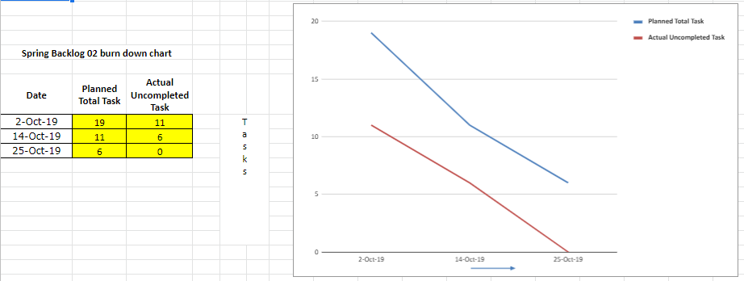

Fig 5.5

**Sprint Backlog- 3**

Basically, Sprint backlog is the set of items that a cross-functional product team selects from its product backlog to work on during the upcoming sprint and take feedback from its previous sprint to enhance the product.

Our Sprint Backlog 3 is upgradation on the previous sprint i.e. In previous sprint we solve only simple expression but now we are going to work on finding the single root or multiple roots of expression and try to solve various types of differentiation & integration. All these types of equations are solved either with the help of image (extracting the expression from image) or we can write these expressions in the text box.

By, completing Sprint backlog 3, we have almost complete the maximum work related to expression that can be solved i.e. solving the normal expression of addition, subtraction to various quadratic equations, differentiation, integration etc.

|  |  |  |  |  |  |  |
| --- | --- | --- | --- | --- | --- | --- |
| **US ID** | **USER STORY** | **TASK ID** | **TASKS** | **TM** | **STATUS (NOT STARTED / IN PROGRESS / COMPLETED)** | **ESTIMATED DATE OF TASK COMPLETION** |
| SB3/US1 | method to find out roots of an expression | SB3/US1/T1 | find the ways to find out the roots of an equation | HS+HA+MG | Completed | 18-Dec-19 |
| SB3/US1/T2 | select the best way to do it | HS+HA+MG | Completed | 18-Dec-19 |
| SB3/US1/T3 | integrate into project | HS+HA+MG | Completed | 18-Dec-19 |
| SB3/US1/T4 | test the project | HS+HA+MG | Completed | 18-Dec-19 |
| SB3/US2 | method to find out roots of multiple expressions | SB3/US2/T1 | find the ways to find out the roots of an equation | HS+HA+MG | Completed | 18-Dec-19 |
| SB3/US2/T2 | select the best way to do it | HS+HA+MG | Completed | 18-Dec-19 |
| SB3/US2/T3 | integrate into project | HS+HA+MG | Completed | 18-Dec-19 |
| SB3/US2/T4 | test the project | HS+HA+MG | Completed | 23-Dec-19 |
| SB3/US3 | method to find out differentiation | SB3/US3/T1 | find the ways to find out the differentiation of an equation | HS+HA+MG | Completed | 23-Dec-19 |
| SB3/US3/T2 | select the best way to do it | HS+HA+MG | Completed | 23-Dec-19 |
| SB3/US3/T3 | integrate into project | HS+HA+MG | Completed | 23-Dec-19 |
| SB3/US3/T4 | test the project | HS+HA+MG | Completed | 23-Dec-19 |
| SB3/US4 | method to find out integration | SB3/US4/T1 | find the ways to find out the integration of an equation | HS+HA+MG | Completed | 23-Dec-19 |
| SB3/US4/T2 | select the best way to do it | HS+HA+MG | Completed | 30-Dec-19 |
| SB3/US4/T3 | integrate into project | HS+HA+MG | Completed | 30-Dec-19 |
| SB3/US5 | integration of all modules | SB3/US5/T1 | add roots finder into project | HS+HA+MG | Completed | 30-Dec-19 |
| SB3/US5/T2 | add differentiation finder into project | HS+HA+MG | Completed | 30-Dec-19 |
| SB3/US5/T3 | add integration finder into project | HS+HA+MG | Completed | 30-Dec-19 |

Fig 5.6

**Sprint Backlog- 3 Burn Down Chart**

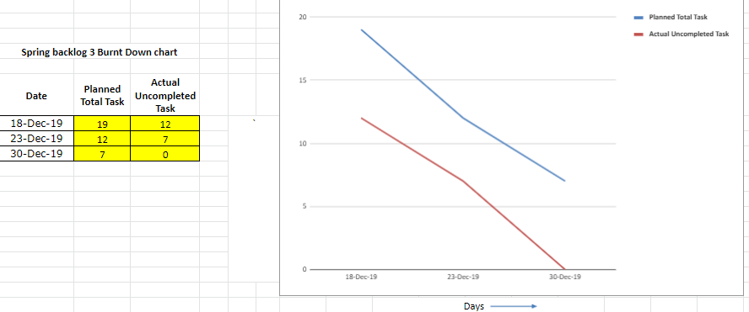

Fig 5.7

**Sprint Backlog- 4**

A sprint backlog provides a team with a transparent focus for the short term while a dynamic product backlog provides a mechanism for the team to gather and remember ideas for future consideration.

Keeping the sprint backlog visible and showing the progress of things provides the team how of communicating status without the additional work of making burn down or burn up charts. a visible representation of the sprint backlog also provides a helpful visual aids for team discussions around current work and what to try to do next.

Our Sprint Backlog 4 is basically based on handwritten expression, for fetching the handwritten expression from image we have to collect the dataset of handwritten alphabet, number, operators and then train the model with the help of Convolution neural network (CNN), we select CNN model because it gives better accuracy than any other models. After model is trained we have to pass the images that contains handwritten expression then the model predicts the expression that written in image and store in new variable, after that it solves the expression and gives the result.

|  |  |  |  |  |  |  |
| --- | --- | --- | --- | --- | --- | --- |
| **US ID** | **USER STORY** | **TASK ID** | **TASKS** | **TM** | **STATUS (NOT STARTED / IN PROGRESS / COMPLETED)** | **ESTIMATED DATE OF TASK COMPLETION** |
| SB4/US1 | Prepare the environment for neural network | SB4/US1/T1 | import keras | HS+HA+MG | Completed | 9-Jan-20 |
| SB4/US1/T2 | import pandas | HS+HA+MG | Completed | 9-Jan-20 |
| SB4/US1/T3 | set required parameters | HS+HA+MG | Completed | 9-Jan-20 |
| SB4/US1/T4 | check the installation | HS+HA+MG | Completed | 9-Jan-20 |
| SB4/US2 | prepare and collect dataset | SB4/US2/T1 | collect hand written numbers dataset | HS+HA+MG | Completed | 9-Jan-20 |
| SB4/US2/T2 | prepare dataset for the required ones | HS+HA+MG | Completed | 9-Jan-20 |
| SB4/US2/T3 | Remove noise from the data set | HS+HA+MG | Completed | 9-Jan-20 |
| SB4/US2/T4 | merge dataset in standard form | HS+HA+MG | Completed | 9-Jan-20 |
| SB4/US3 | create model | SB4/US3/T1 | search the available models for the data set | HS+HA+MG | Completed | 16-Jan-20 |
| SB4/US3/T2 | train dataset from different model | HS+HA+MG | Completed | 16-Jan-20 |
| SB4/US3/T3 | find out the scores of all models | HS+HA+MG | Completed | 16-Jan-20 |
| SB4/US3/T4 | find out the best model | HS+HA+MG | Completed | 16-Jan-20 |
| SB4/US4 | testing of the model | SB4/US4/T1 | test the model with the dataset present | HS+HA+MG | Completed | 16-Jan-20 |
| SB4/US4/T2 | test the model with the appropriate input | HS+HA+MG | Completed | 23-Jan-20 |
| SB4/US4/T3 | create the pickle file | HS+HA+MG | Completed | 23-Jan-20 |
| SB4/US5 | Test the complete flask app | SB4/US5/T1 | Deploy the flask app | HS+HA+MG | Completed | 23-Jan-20 |
| SB4/US5/T2 | Give input in image format to check the result | HS+HA+MG | Completed | 23-Jan-20 |
| SB4/US5/T3 | Give input in text format to check the result | HS+HA+MG | Completed | 23-Jan-20 |

Fig 5.8

**Sprint Backlog- 4 Burn Down Chart**

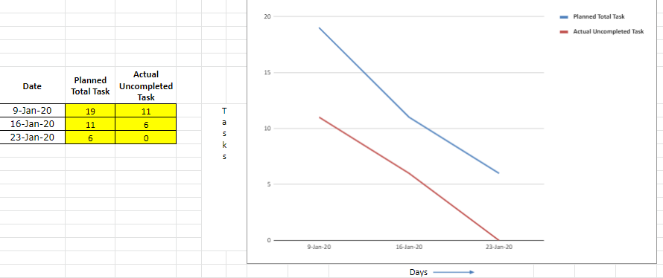

Fig 5.9

**Chapter 6: Project Implementation**

**Sprint Backlog- 1**

Our Sprint Backlog-1 is basically based on the understand the requirements of tools & technologies, understand the future scope of the project, select the appropriate language to work on the project, install the required libraries to configure the system and create a model that extract simple expression from the image and solve that expression extracted from image. For starting phase generate the expression in image with the help of MS-Paint software. After getting the result test the accuracy of the program.

**Expressions (Store in png format)**

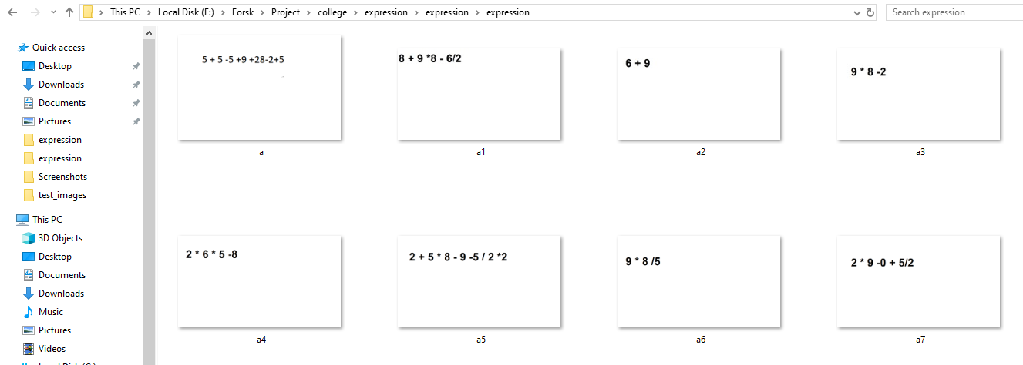**Fig 6.01**

**Sample code for fetch and solve the expression from Image**

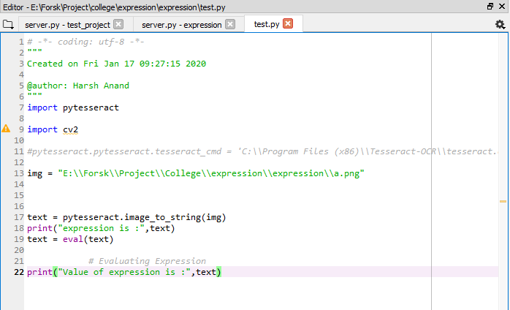

**Fig 6.02**

**Result after solving the expression from Image**

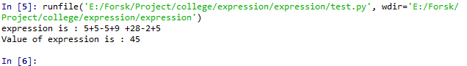

**Fig 6.03**

**Sprint Backlog- 2**

Our Sprint Backlog 2 is based on designing the UI with the help of HTML, CSS, Bootstrap, JavaScript and deploy the python code with UI can be done with the help of Flask app. In UI, we have design an input box that take file(image) as input and after taking input it displays the image in another box and after click on submit it display the result on same page. Without reloading the UI, we have to display the result, so that we can use AJAX. At last create a Text box in UI, so that we can type the expression also rather taking images every time.

**Expressions (Store in png format)**



**Fig 6.04**

**UI for our Project**

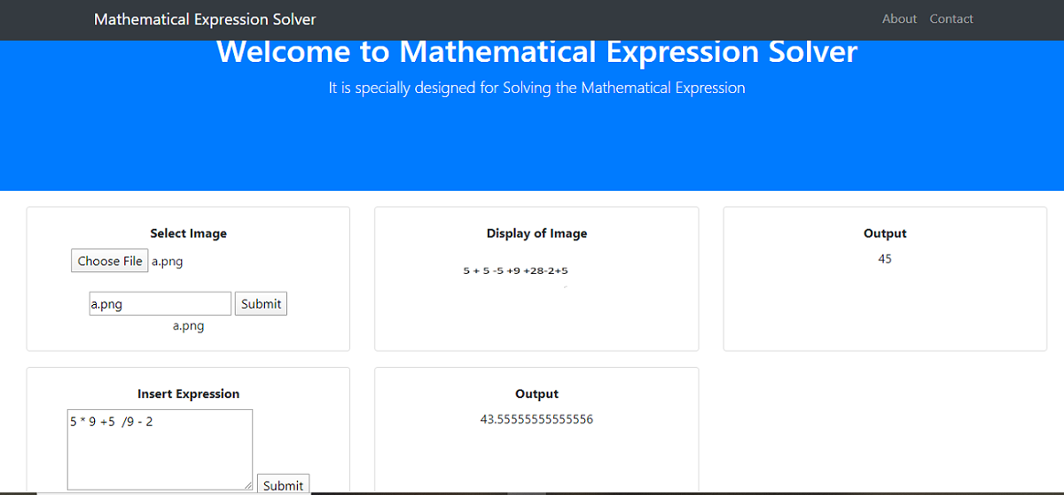

**Fig 6.05**

**Sample Code for UI connect with flask**

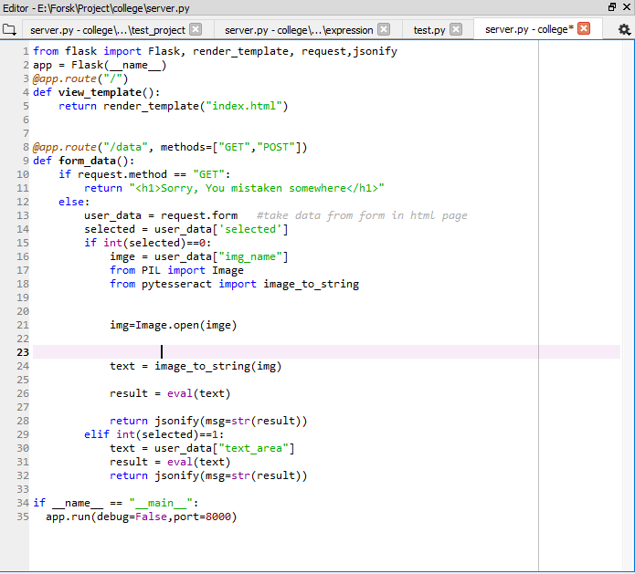

**Fig 6.06**

**Sprint Backlog- 3**

Our Sprint Backlog 3 is upgradation on the previous sprint i.e. In previous sprint we solve only simple expression but now we are going to work on finding the single root or multiple roots of expression and try to solve various types of differentiation & integration. All these types of equations are solved either with the help of image (extracting the expression from image) or we can write these expressions in the text box.

By, completing Sprint backlog 3, we have almost complete the maximum work related to expression that can be solved i.e. solving the normal expression of addition, subtraction to various quadratic equations, differentiation, integration etc.

**Sample Code of UI Integrate with Flask**

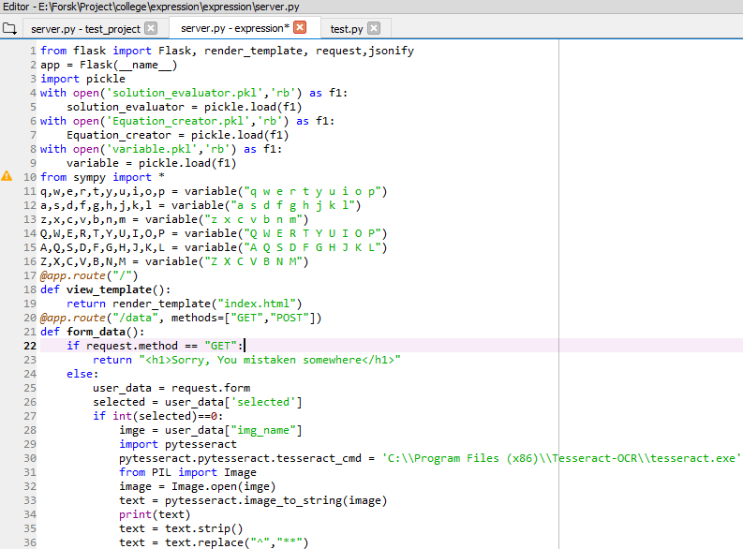

**Fig 6.07**

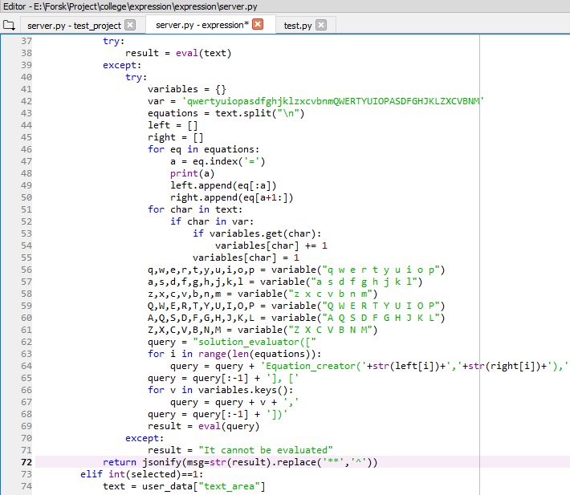

**Fig 6.08**

**Expression (Store in png format)**

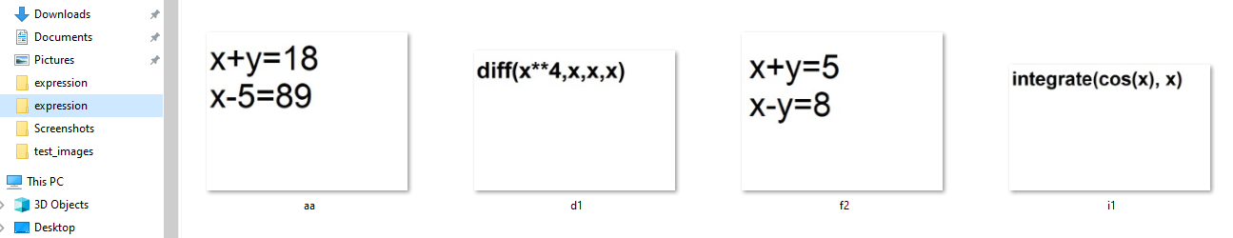

**Fig 6.09**

**UI for our project**

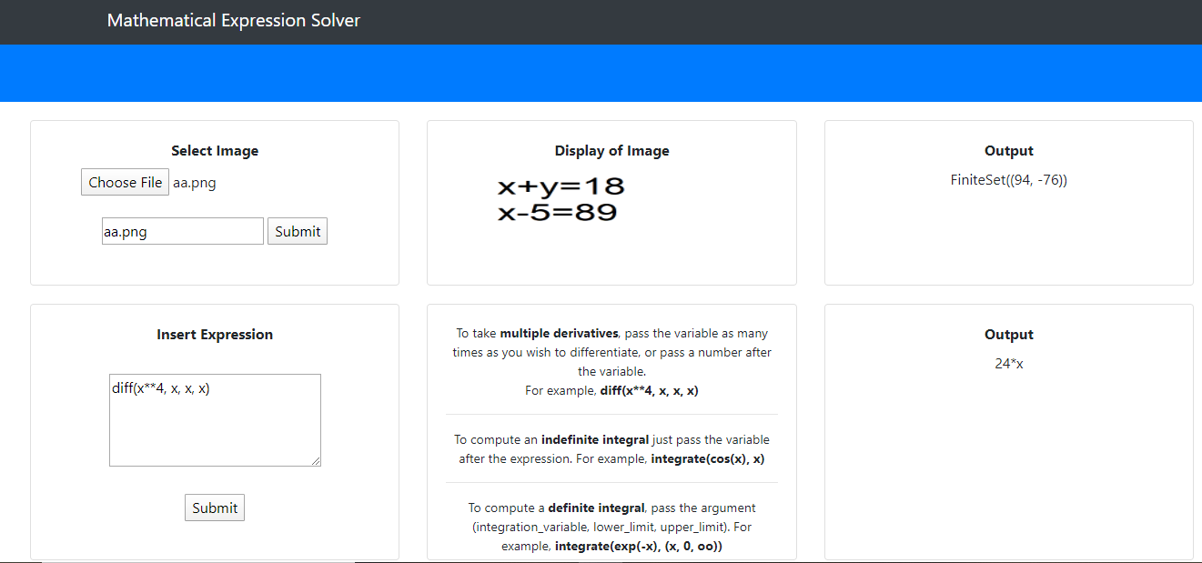

**Fig 6.10**

**Sprint Backlog- 4**

Our Sprint Backlog 4 is basically based on handwritten expression, for fetching the handwritten expression from image we have to collect the dataset of handwritten alphabet, number, operators and then train the model with the help of Convolution neural network (CNN), we select CNN model because it gives better accuracy than any other models. After model is trained we have to pass the images that contains handwritten expression then the model predicts the expression that written in image and store in new variable, after that it solves the expression and gives the result.

**Handwritten Expression (Store in png format)**



**Fig 6.11**

**Sample code for training model for handwritten expression**

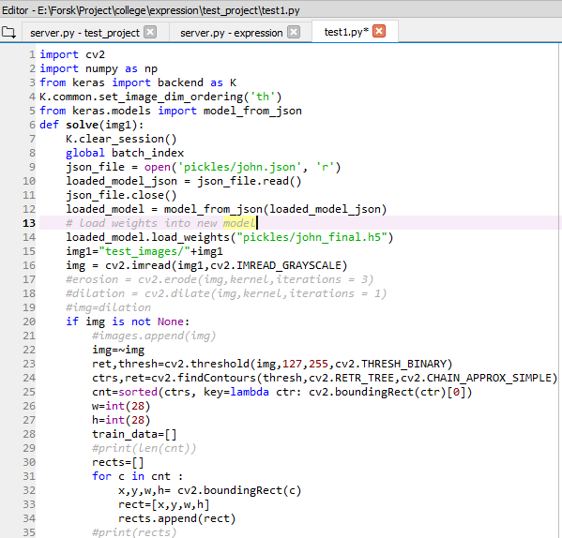

**Fig 6.12**

**Sample Flask app (handwritten)**

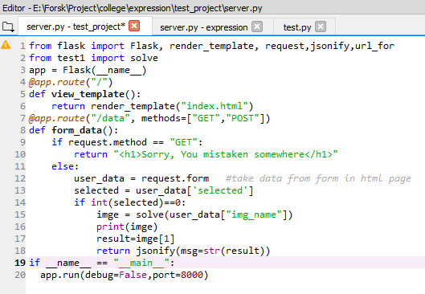**Fig 6.13**

**UI for Handwritten Expression Solver**

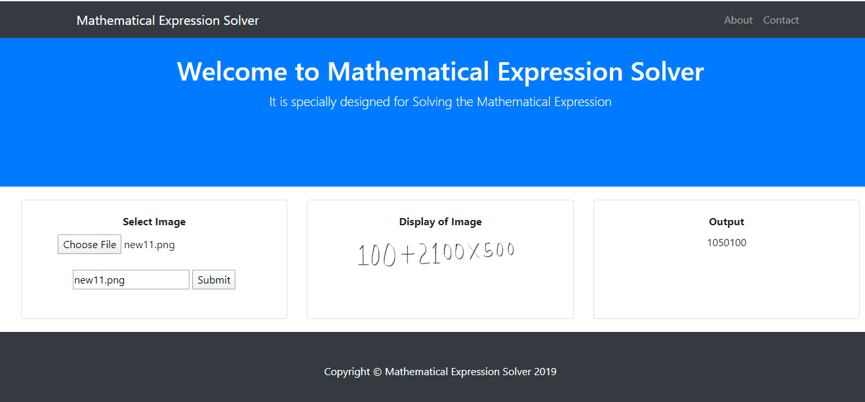

**Fig 6.14**

**Chapter 7**

**Results**

Mathematical expression solver can evaluate the expressions which are either printable text or handwritten expression without any error and the expression can be a simple expression or it can be an expression with the variable (linear, quadratic, etc.) or it can be the expression with the keyword diff and integrate where integrate is used for the expression in which we have to find out the integration of the expression. We can also set the limits to it that means we can find the integration which has limits. diff is used where we have to find out the differentiation of the expression.

**Future Scope**: Now we are getting the images in the form of images but in future, we will use the webcam to get the algebraic expression. Whatever we are writing in front of webcam our project will evaluate the solution. Our project will also able to find the value of the independent variable. This will also able to solve the quadratic expression and ability to write the multiple values of undefined variables write now it is doing that for printable text only in future we will try to do the same for the handwritten expressions. This project will also able to do the comparison operation and will return the result in the form of Boolean values like true or false write now it is doing that for printable text only in future we will try to do the same for the handwritten expressions.

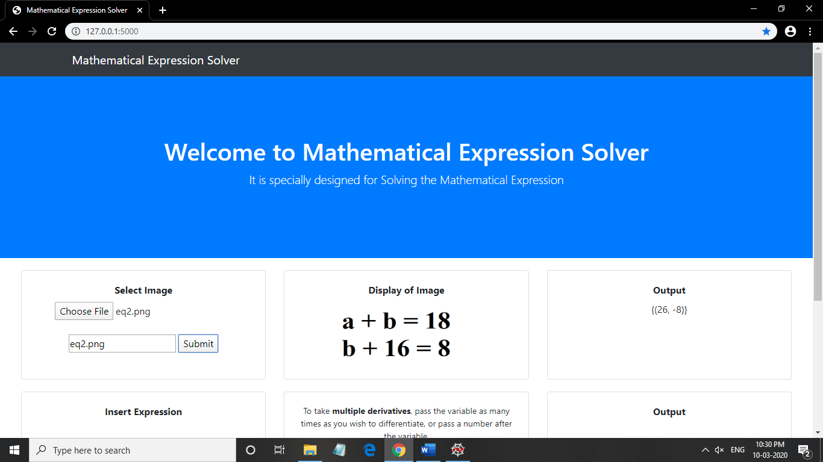

Fig 7.01

In the above example, we take the image of an expression which is written in the printable text format and then after fetching the expression our project applies the optimal algorithm to find out the result of the expression and after getting the result it is shown on the interface using flask.



Fig 7.02

In the above example, we take the image of an expression which is written in the handwritten text format and then after fetching the expression our project applies the optimal algorithm to find out the result of the expression and after getting the result it is shown on the interface using flask.

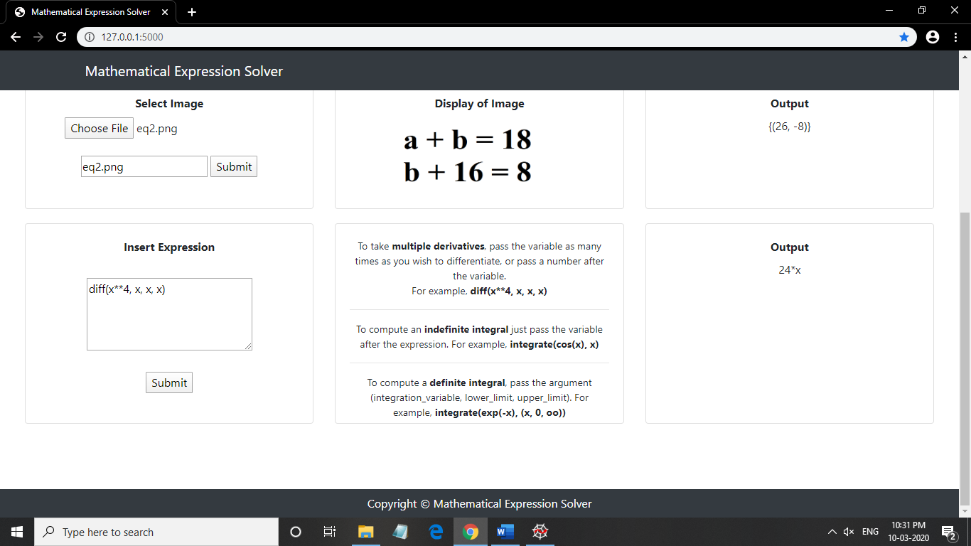

Fig 7.03

In the above example, we write an expression using keyword diff which is used to evaluate the differentiation after fetching the expression our project applies the optimal algorithm to find out the result of the expression and after getting the result it is shown on the interface using flask.

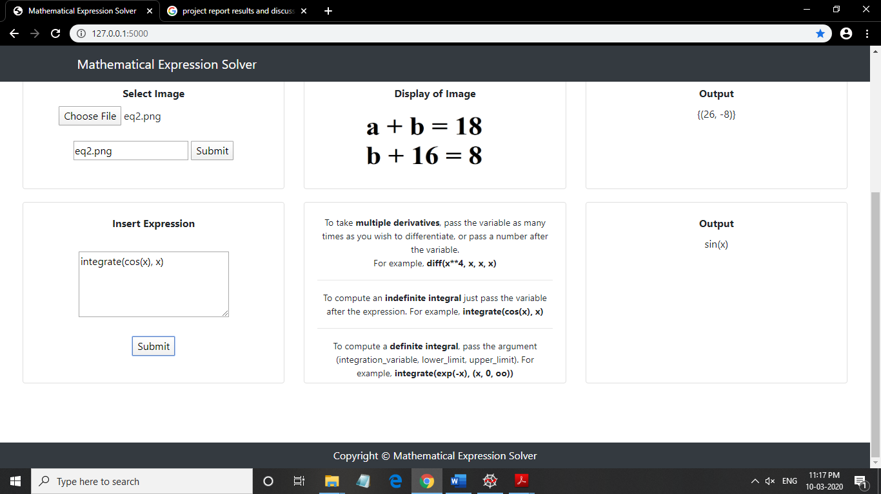

Fig 7.04

In the above example, we write an expression using keyword integrate which is used to evaluate the integration after fetching the expression our project applies the optimal algorithm to find out the result of the expression and after getting the result it is shown on the interface using flask.

**ANNEXURES**

**References: -**

* [www.quora.com](http://www.quora.com)
* [www.wikipidia.com](http://www.wikipidia.com)
* [www.scikitlearn.com](http://www.scikitlearn.com)
* [www.github.com](http://www.github.com)
* [www.stackoverflow.com](http://www.stackoverflow.com)
* [https://kaggle.com/datasets](https://www.kaggle.com/datasets)